High Electric Demand Days and Visibility Impairment in MANE-VU

MANE-VU Technical Support Committee

10/17/2017

Acknowledgements
The paper has been the effort of MANE-VU Technical Support Committee’s Four-Factor Workgroup. Rob Sliwinski of New York Department of Environmental Conservation chaired the Technical Support Committee, whom were responsible for review of the report. Claire Sickinger, Kate Knight, and Kurt Kebschull from Connecticut Department of Energy and Environmental Protection; Mark Wert and Azin Kavian from Massachusetts Department of Environmental Protection; Mary Jane Rutkowski from Maryland Department of the Environment; Tom Downs, Tom Graham and Martha Webster from Maine Department of Environmental Protection; David Healy from New Hampshire Department of Environmental Services; Ray Papalski, Stella Oluwaseun-Apo, and Victoria Faranca from New Jersey Department of Environmental Protection; Scott Griffin and Amanda Chudow from New York Department of Environmental Conservation; Bryan Oshinski from Pennsylvania Department of Environmental Protection and Bennet Leon and Dan Riley of Vermont Department of Environmental Conservation provided valuable insights as the project progressed. Maine staff was particularly instrumental in the visibility data back trajectory analyses, and Claire Sickinger, Stella Oluwaseun-Apo, and Amanda Chudnow each conducted independent analysis of ISO-NE, PJM, and ISO-NY respectively that made up the bulk of the energy demand analysis. Joseph Jakuta managed the workgroup as MANE-VU staff.

Table of Contents
Introduction 1
Scope and Domain 1
HEDD Analysis 3
Electric Load Data 3
Visibility Data Analysis 6
Best Visibility Days Analysis 6
20% Most Impaired Visibility Day Analysis 6
HYSPLIT Analysis of Most Impaired Visibility Days 11
Meteorological Factors 14
Analysis of Days Preceding the Most Impaired Visibility Days 15
Conclusions 20

Introduction
The Federal Clean Air Act and Regional Haze rule require States that are reasonably anticipated to cause or contribute to impairment of visibility in mandatory Class I Federal areas to implement reasonable measures to reduce visibility impairment within the national parks and wilderness areas designated as mandatory Class I Federal Areas. To address the impact on Class I Federal areas within the Mid-Atlantic /Northeast Visibility Union (MANE-VU) region, the MANE-VU States will pursue a coordinated course of action to assure reasonable progress toward preventing any future, and remedying any existing impairment of visibility in mandatory Class I Federal areas. This course of action includes pursuing the adoption and implementation of emission management strategies.
One of the emission management strategies that will be considered for adoption and implementation by the MANE-VU Class I States is for the MANE-VU States to perform a four-factor analysis for peaking combustion turbines that operate on high electric demand days to address and control oxides of Nitrogen (NOx) and sulfur dioxide (SO2) emissions, where:
- “High Electric Demand Day or “HEDD” is defined as the day when higher than usual electrical demands bring additional generation units online, many of which are infrequently operated and may have significantly higher emission rates than the rest of the generation fleet and,
- “Peaking combustion turbine” is defined for the purposes of the MANE-VU “Ask” as a turbine capable of generating 15 megawatts or more, that commenced operation prior to May 1, 2007, used to generate electricity all or part of which is delivered to the electric power distribution grid for commercial sale, and that operates less than or equal to an average of 1752 hours (or 20%) per year during 2014 to 2016.
This analysis reviews visibility and energy data to determine the impact electric load has on visibility impairment, specifically the impacts of HEDDs on the “20% most impaired visibility days,” though it also looks at the older 20% worst day metric as well.

Scope and Domain
As discussed in the above, the purpose of this study is to review the impact of ISO-NE, ISO-NY, and PJM HEDD on the MANE-VU region’s visibility. Therefore, the analysis encompasses two domains: that of ISO-NE, ISO-NY, and PJM for the HEDD analysis and that of MANE-VU (plus some neighboring areas) for the visibility impairment analysis.
Specifically, the following figures depict the region analyzed for HEDD; the Independent System Operator (ISO) for the energy distribution in New England (Figure 1), the ISO for energy distribution in New York (Figure 2) and the Regional Transmission Organization (RTO) for the Mid-Atlantic, PJM (Figure 3). ISO-NE is responsible for administering the power plants, maintaining the electric grid, and operating the power market for the region.

Figure 1: ISO-NE region and load zones within the region  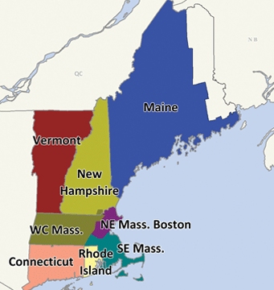 | Figure 2: ISO-NY region and load zones within the region  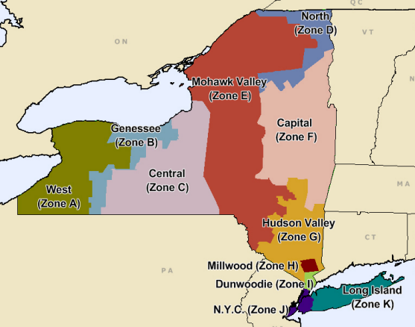
Figure 3: PJM region and load zones within the region
The region examined for the visibility impairment includes all of the MANE-VU. The states included in MANE-VU are Maine, New Hampshire, Vermont, Rhode Island, Massachusetts, Connecticut, New York, New Jersey, Delaware, Maryland, Pennsylvania, and the District of Columbia. Nearby states that are not in MANE-VU but frequently impact visibility in MANE-VU are also included in portions of the analysis, the extent of which was determined by the extent the air mass traveled in a 72-hour period. Within the MANE-VU region, the federally designated Class I areas are Brigantine Wilderness Area in the Edwin B. Forsythe National Wildlife Refuge (Brigantine), New Jersey; Lye Brook Wilderness (Lye Brook), Vermont; Great Gulf Wilderness and Presidential Range - Dry River Wilderness (Great Gulf), New Hampshire; Acadia National Park (Acadia), and Moosehorn Wilderness (Moosehorn), Maine; and Roosevelt Campobello International Park, Maine/New Brunswick, Canada.
The scope of the analysis was originally intended to only review the most recent set of data that both IMPROVE (Interagency Monitoring of Protected Visual Environments) monitoring and HEDD data have available, 2015.

HEDD Analysis
HEDD are defined as the 85th percentile of the daily peak demand. The 85th percentile was chosen to evaluate HEDD in part to be consistent with the analyses of the surrounding ISOs/RTOs and in part because it approximates the value which was determined to be an appropriate definition of HEDD for the New Jersey HEDD rule. This section evaluated the daily peak demand data for 2015 to define the HEDDs to compare against visibility impairment in the following sections.

Electric Load Data
Electric load data was obtained from the ISO-NE, ISO-NY, and PJM Interconnection. ISO-NE covers the six New England states and ISO-NY solely covers New York. PJM Interconnection is a regional transmission organization (RTO) that coordinates the movement of wholesale electricity in all or parts of Delaware, Illinois, Indiana, Kentucky, Maryland, Michigan, New Jersey, North Carolina, Ohio, Pennsylvania, Tennessee, Virginia, West Virginia and the District of Columbia.
As shown in Table 1, the two 85th percentile values for all three ISOs/RTOs are very close showing that we can rely on the 85th percentile on days monitored by IMPROVE.
Table 2 expands on this information by looking at the average peak generation on 20% most impaired days and HEDDs. There is a noticeable difference in the average maximum daily load between 20% most impaired days using all three ranking systems and the other days monitored by IMPROVE. The difference is even more noticeable between HEDDs and non HEDDs.
Table 1: Maximum, 85th Percentile, and 85th Percentile maximum daily generation (MWh) on IMPROVE monitored days
 | ISO-NE | ISO-NY | PJM
Maximum | 24,074 | 18,168 | 143,633
85th Percentile | 19,331 | 11,432 | 122,756
85th Percentile on IMPROVE Days | 19,261 | 11,515 | 122,252

Table 2: Average Generation (MWh) in each ISOs/RTOs on most impaired days and other monitored days ranked using three methods and on HEDDs and non-HEDDS on monitored days at each Class I Area.
 | Old Ranking |  | Anthropogenic Ranking |  | Impairment Ranking |  | HEDD on Monitored Day |  | All Monitored Days
 | Top 20% | Other Days | Top 20% | Other Days | Top 20% | Other Days | Y | N
Acadia | 48,866 | 41,975 | 47,617 | 42,284 | 47,617 | 42,284 | 55,363 | 41,102 | 43,341
ISO-NE | 19,222 | 16,430 | 18,600 | 16,583 | 18,600 | 16,583 | 21,171 | 16,203 | 16,983
ISO-NY | 10,915 | 8,368 | 9,918 | 8,615 | 9,918 | 8,615 | 13,617 | 7,990 | 8,874
PJM | 116,461 | 101,126 | 114,332 | 101,653 | 114,332 | 101,653 | 131,301 | 99,113 | 104,168
Brigantine | 48,448 | 42,078 | 47,601 | 42,288 | 47,601 | 42,288 | 55,363 | 41,102 | 43,341
ISO-NE | 18,918 | 16,505 | 18,382 | 16,637 | 18,382 | 16,637 | 21,171 | 16,203 | 16,983
ISO-NY | 10,845 | 8,386 | 10,181 | 8,550 | 10,181 | 8,550 | 13,617 | 7,990 | 8,874
PJM | 115,582 | 101,343 | 114,240 | 101,675 | 114,240 | 101,675 | 131,301 | 99,113 | 104,168
Great Gulf | 50,842 | 41,371 | 47,410 | 42,146 | 47,410 | 42,146 | 57,504 | 40,418 | 43,116
ISO-NE | 19,397 | 16,313 | 18,663 | 16,479 | 18,663 | 16,479 | 21,373 | 16,094 | 16,881
ISO-NY | 11,787 | 8,194 | 10,026 | 8,592 | 10,026 | 8,592 | 13,732 | 7,942 | 8,856
PJM | 121,342 | 99,605 | 113,541 | 101,367 | 113,541 | 101,367 | 131,301 | 98,071 | 103,609
Lye Brook | 48,467 | 42,025 | n/a | n/a | n/a | n/a | 57,652 | 40,734 | 43,279
ISO-NE | 18,796 | 16,470 | n/a | n/a | n/a | n/a | 21,089 | 16,185 | 16,923
ISO-NY | 11,258 | 8,225 | n/a | n/a | n/a | n/a | 13,779 | 7,996 | 8,815
PJM | 115,345 | 101,379 | n/a | n/a | n/a | n/a | 131,181 | 98,967 | 104,098
Moosehorn | 48,936 | 42,367 | 48,271 | 42,533 | 48,271 | 42,533 | 55,363 | 41,242 | 43,681
ISO-NE | 19,156 | 16,596 | 18,925 | 16,653 | 18,925 | 16,653 | 21,171 | 16,259 | 17,108
ISO-NY | 10,816 | 8,575 | 10,233 | 8,721 | 10,233 | 8,721 | 13,617 | 8,064 | 9,023
PJM | 116,835 | 101,930 | 115,656 | 102,225 | 115,656 | 102,225 | 131,301 | 99,401 | 104,911
Grand Total | 49,080 | 41,960 | 47,723 | 42,534 | 47,723 | 42,534 | 56,205 | 40,921 | 43,349

Figure 4 shows the electric demand (dots) for 2015 for each ISOs/RTOs with blue being ISO-NE, orange being ISO-NY, and green being PJM. The lighter lines represent the 85th percentile of daily demand for the year, while the darker lines represent the 85th percentile of electric demand on IMPROVE days. There is a clear spike in electric demand during the summer months in all ISOs/RTOs, with a lesser spike during the winter months, with some of the lower demand values occurring in spring and fall.
Figure 4: Peak daily demand (GWh) in ISO-NE (blues, right scale), ISO-NY (oranges, right scale), and PJM (greens, left scale) 2015

Figure 5, shows which IMPROVE monitored days occurred during 85th percentile days, 85th percentile IMPROVE monitored days, or both. In all of three ISOs/RTOs the HEDDs begin occurring in mid to late-May and extend throughout the summer ending in early to mid-September. In all three ISOs/RTOs there are also HEDDs that occur during January and February.

Figure 5: Peak daily demand (GWh) on IMPROVE sample days, 2015

Visibility Data Analysis
The following portion of the analysis reviews the visibility impairment at the MANE-VU and nearby Class I areas and evaluates any/if any correlation in the occurrence in impairment and HEDD. The full visibility analysis was prepared by Maine DEP for MANE-VU and will be released as a separate report.

Best Visibility Days Analysis
A comparison of the visibility values against the HEDD were also evaluated. If the correlation was similar to the worst days, it might indicate that HEDD sources are not significant in the issue of visibility impairment. However, this analysis revealed that the occurrence of a HEDD day on the days deemed “best visibility” was in fact significantly rarer than the occurrence with impaired days as seen in Table 3. Great Gulf did not have a best day occur on the same day as a HEDD in any ISO/RTO. Acadia and Moosehorn had one best day occur on the same day as a HEDD in ISO-NE. Brigantine and Lye Brook both only had one best day occur during a HEDD in ISO-NY. Acadia and Moosehorn also had two best days occur during HEDDs in ISO-NY and PJM, respectively. It would be expected that HEDDs would not occur on best visibility days and that expectation appears correct.
Table 3: Number of HEDDs on Best Days
Site | Monitored Days | ISO-NE | ISO-NY | PJM
ACAD1 | 23 | 1 | 2 | 0
BRIG1 | 23 | 0 | 1 | 0
GRGU1 | 21 | 0 | 0 | 0
LYEB1 | 21 | 0 | 1 | 0
MOOS1 | 21 | 1 | 1 | 2

20% Most Impaired Visibility Day Analysis
The data shown in both Table 4 and Figure 6 demonstrate that poor visibility days often occur on HEDDs. Table 4 shows the counts of the number of 20% most impaired days using three different ranking techniques and find that between 57% and 29% of all HEDDs occur on the most impaired days depending on the ranking methodology and which ISO/RTO is being looked at. Since the impairment method can remove days from consideration that experience both high impact from fires and anthropogenic emissions that would go to explain that decrease in number of HEDDs seen on most impaired days.
Table 4: Number of HEDDs on 20% Most Impaired using three ranking techniques
 |  | Old Rank |  |  | Anthropogenic |  |  | Impairment
Site | Monitored Days | ISO-NE | ISO-NY | PJM | ISO-NE | ISO-NY | PJM | ISO-NE | ISO-NY | PJM
ACAD1 | 24 | 12 | 11 | 11 | 11 | 10 | 10 | 8 | 8 | 10
BRIG1 | 24 | 9 | 10 | 7 | 9 | 9 | 7 | 8 | 7 | 7
GRGU1 | 21 | 11 | 11 | 12 | 9 | 9 | 11 | 7 | 7 | 8
LYEB1 | 22 | 9 | 10 | 7 | n/a | n/a | n/a | n/a | n/a | n/a
MOOS1 | 22 | 10 | 9 | 9 | 11 | 10 | 10 | 9 | 9 | 9

The middle quintile rankings were not available in data sets for the anthropogenic and impairment methods so we also looked strictly at the old “worst day” ranking to see when HEDDs occurred on other impairment days. Figure 6 shows that the 20% worst days clearly line up with HEDDs and decrease as visibility improves.
Figure 6: Total HEDDs in each ISO/RTO during each quintile of day using the old “worst day” method

Figure 7 shows the speciation analyses for the 20% most impaired visibility days and Figure 8 shows the speciation analyses for the 20% most impaired visibility days at each MANE-VU Class I Area in 2015. We only looked at speciation on the 20% worst days and the 20% most impaired days using the impairment method, since all 20% most impaired days calculated using the anthropogenic method were included in one of the other sets of days. Lye Brook was not included since 20% most impaired data was not available for 2015.
The HEDD that occur on the most impaired days for each Class I Area are distinguished by the label with their percentile ranking. Ammonium sulfate has the highest extinction year-round at all Class I Areas except Brigantine, which showed multiple instances of ammonium nitrate extinction exceeding that of ammonium sulfate, however only one of those corresponded to a HEDD. At all Class I Areas, ammonium nitrate extinction was highest in the cooler months and lowest in the warmer months. Organic mass extinction was significant in all Class I Areas and elemental carbon only stood out as a significant contributor on a few days at Brigantine. Sea salt extinction was noticeable at Acadia and Brigantine, and on one day at Moosehorn, which was also a HEDD, however sea salt not a pollutant that would indicate energy sources were the cause. More than half of the 20% most impaired days occurred in the winter and summer for all areas in 2015.

Figure 7: Speciation (left axis) of the 20% most impaired days and the maximum daily load (GWh) (right axis) in ISO-NE, ISO-NY, and PJM with HEDDs noted in orange at each Class I Area.
Figure 8: Speciation (left axis) of the 20% worst days and the maximum daily load (GWh) (right axis) in ISO-NE, ISO-NY, and PJM with HEDDs noted in orange at each Class I Area.

HYSPLIT Analysis of Most Impaired Visibility Days
The HYSPLIT model was used to develop 72-hour back trajectories at 500m four times per day (3 AM, 9 AM, 3 PM, and 9 PM) to determine the wind patterns on the most impaired days. These back trajectories were developed for a previous report by Maine DEP. Back trajectories were not developed for the 20% worst days for this report so only the 20% most impaired days as ranked using the impairment method were used. The trajectories were overlaid on a map of the area covered by each of the ISOs/RTOs to graphically display how the wind patterns matched with the foot print of the ISOs/RTOs. The back trajectories that went over the geography of the ISO/RTO during the days that were a HEDD were highlighted.
Figure 9 shows the back trajectories during 20% most impaired days for Acadia, Great Gulf, and Moosehorn, respectively, which occurred during a HEDD in at least one ISO/RTO. The patterns in each map are similar with the most back trajectories in ISO-NE, and several crossing ISO-NY and PJM. It would be reasonable to expect that all three ISOs/RTOs analyzed could play a role in impacting visibility conditions in each of those Class I areas.
Figure 9: 72-hour back trajectories at 3 AM & PM and 9 AM & PM from Moosehorn during 20% most impaired days that were HEDDs in one analyzed ISO/RTO at 500m
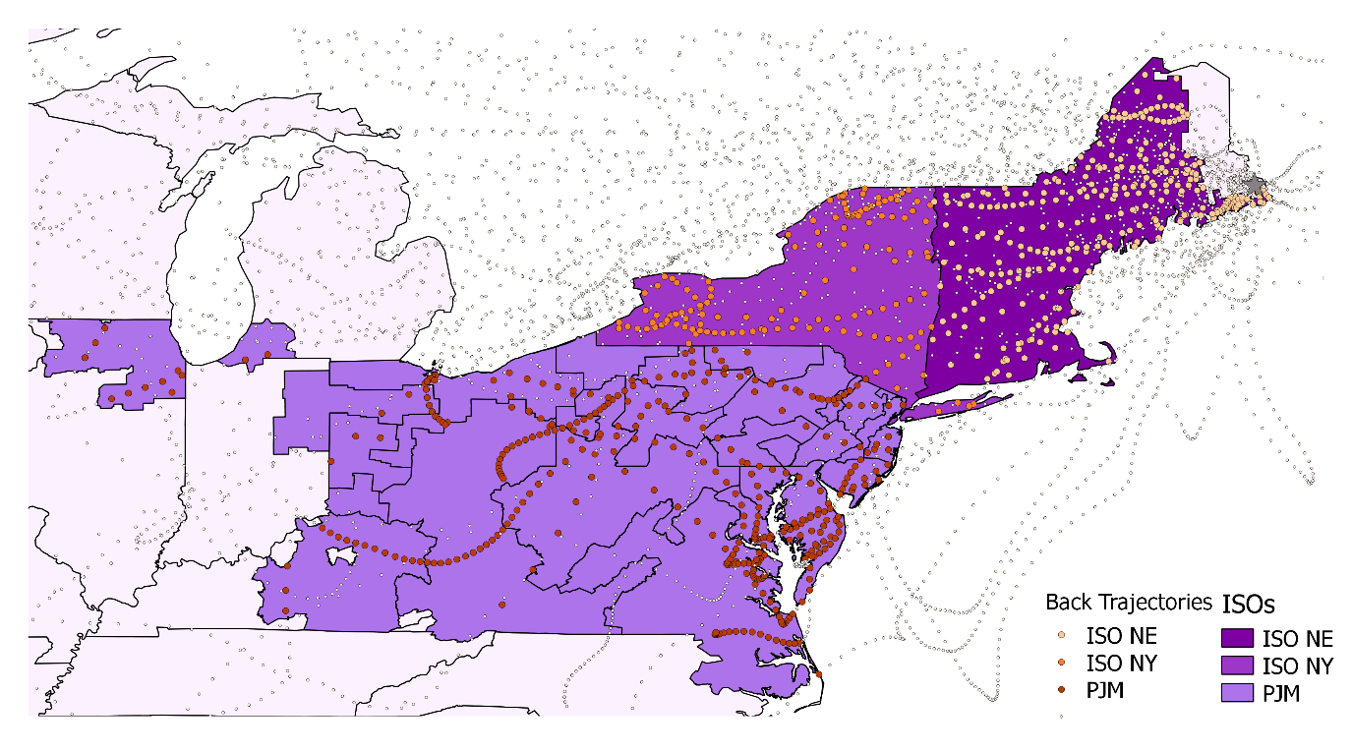

Figure 10: 72-hour back trajectories at 3 AM & PM and 9 AM & PM from Acadia during 20% most impaired days that were HEDDs in one analyzed ISO at 500m
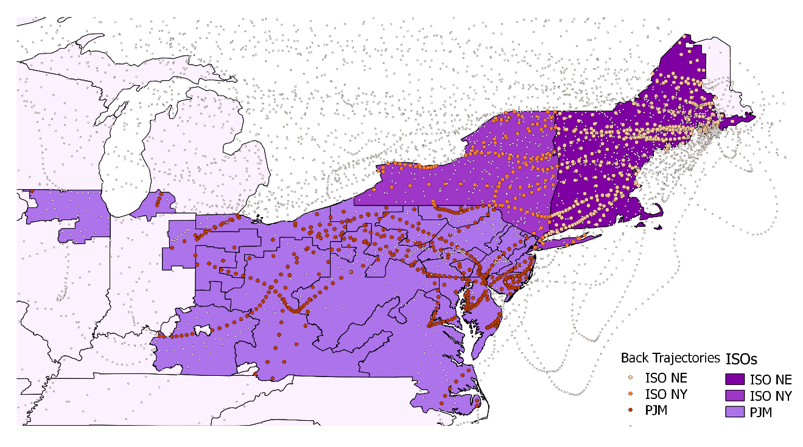
Figure 11: 72-hour back trajectories at 3 AM & PM and 9 AM & PM from Great Gulf during 20% most impaired days that were HEDDs in one analyzed ISO/RTO at 500m
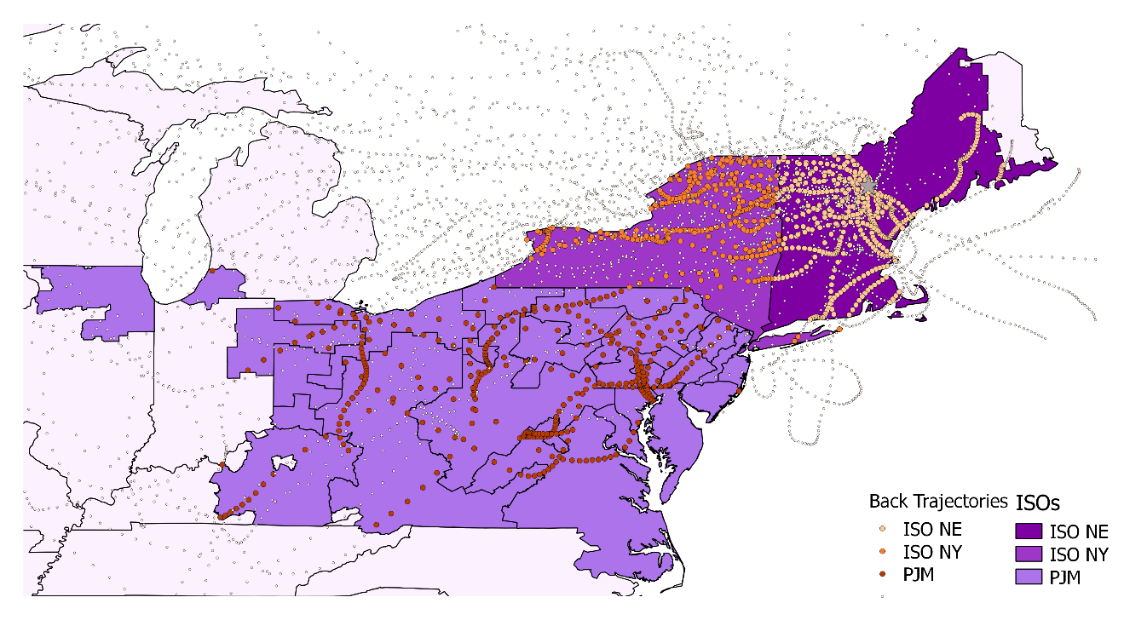

Figure 12 shows the back trajectories during 20% most impaired days for Lye Brook that occurred during a HEDD in at least one ISO/RTO. The pattern for Lye Brook is similar to that of the other New England Class I Areas, except due to it being on the western side of ISO-NE, the impact of ISO-NY would appear to be greater and that of ISO-NE to be minimal.
Figure 12: 72-hour back trajectories at 3 AM & PM and 9 AM & PM from Lye Brook during 20% most impaired days that were HEDDs in one analyzed ISO/RTO at 500m
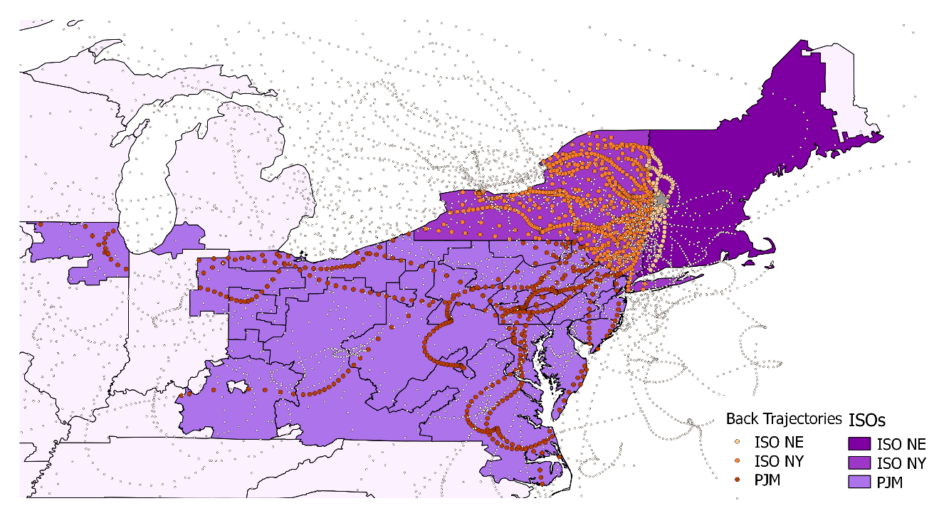

Figure 13 shows the back trajectories during 20% most impaired days for Brigantine that occurred during a HEDD in at least one ISO/RTO. It is clear from the trajectories that, in 2015, ISO-NE has little influence on poor visibility at Brigantine, but emissions from PJM are an important indicator of poor visibility during HEDDs. ISO-NY could potentially have an impact on visibility issues in Brigantine as well, especially from the western part of the ISO/RTO.
Figure 13: 72-hour back trajectories at 3 AM & PM and 9 AM & PM from Brigantine during 20% most impaired days that were HEDDs in one analyzed ISO/RTO at 500m
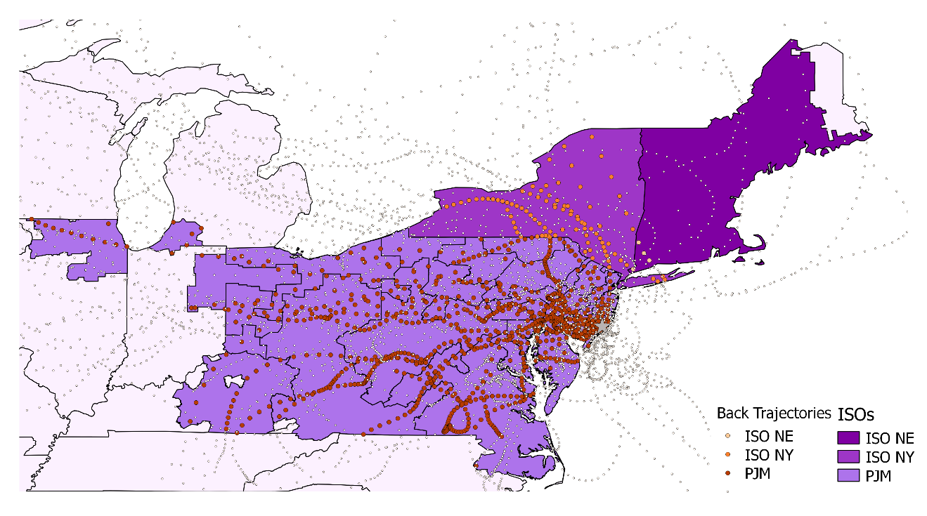

Meteorological Factors

Brigantine
Preliminary meteorological analysis shows that on HEDD and on the most impaired days, a common meteorological feature, called a low pressure surface trough or the Appalachian Lee-side Trough (APLT), exists that creates favorable conditions for poor visibility at Brigantine. This feature allows polluted air aloft to easily mix down to the surface and combine with local emissions. This feature is frequently seen west of New Jersey on days prior to as well as on the most impaired days. In addition, on days when extreme temperatures cause electricity generating units to operate at a higher capacity due to increased demand, increased pollutant levels is released into the atmosphere. As a result, downwind locations may see an increase in haze or pollutant concentrations on the next day.
Calm winds at the coast are also commonly seen on days of visibility impairment at Brigantine. Calm winds create poor atmospheric ventilation for pollutants to disperse in the atmosphere. Brigantine’s unique location near the coast makes it an ideal downwind endpoint for pollutants to accumulate that travel from the west. If any units operate without controls on days prior to the most impaired days, a greater amount of pollution from upwind States travels eastward to Brigantine. Persistence can also be a factor, i.e., when there are several days of stagnation during prolonged hot or cold periods. Extended periods of extreme temperatures with little atmospheric ventilation can cause electric generating units to operate at higher levels of demand for several days in a row, during which pollutants accumulate in the same location when there is poor atmospheric ventilation. As a result, when finally the heavily polluted air mass is pushed downwind, it creates poor visibility in the downwind areas.

New England Class I Areas
Poor visibility can be associated with several weather patterns during winter and summer months at the New England Class I Areas. During the summer, high pressure moving from the Midwest to off the coast of the Mid-Atlantic States setting up a Bermuda High with west to southwest transport winds leads to impairment in New England’s Class I areas. Another pattern that leads to the transport of visibility impairing pollution to New England Class I areas is the Lee-side Trough, which sets up resulting in Southwest flow of pollutants from large cities in the Northeast to New England’s Class I areas. The Lee-side Trough also help turn the winds in the Gulf of Maine resulting in transported pollution to Maine’s Class I areas by sea breezes. Finally, southerly winds can transport pollution from large cities in the Northeast to the New Hampshire and Vermont Class I areas.
Meteorological conditions that lead to visibility impairment in the winter differ from those in the summer at New England Class I areas. In some instances very cold air masses sit in place resulting in a HEDD with higher power plant emissions and higher residential heating emissions. Winds tend to be more from the Northwest in these events with emissions from Canada also contributing to the pollution at New England Class I areas. In other situations, a high pressure system moving into the Northeast from the Midwest and large cities in the Northeast will set up a subsidence inversion pushing aloft transported pollution closer to the surface. This type of event is much warmer than the HEDD events and are more polluted with a stalled or slow moving High Pressure system and can happen in any season of the year. Finally, nighttime inversions will trap pollutants near the surface. Pollution levels are higher during the winter during these inversions because they last longer than in any other season. Inland Class I areas are more impacted by this type of event.

Analysis of Days Preceding the Most Impaired Visibility Days
Electric load data from the three ISOs/RTOs were reviewed for two days preceding the most impaired days for two of the methods (anthropogenic was left off since all 20% most impaired days using that ranking were in the other two sets of days). The two methods showed similar characteristics.
As one can see in Table 5, 20% most impaired days are preceded in the day before and two days before by HEDDs only slightly less often than when they occur on the same day as HEDDs in the different ISOs. In the case of the worst ranking between 50% and 23% of most impaired days are preceded by a HEDD in a particular ISO/RTO and 43% and 17% of most impaired days are preceded by a HEDD two days before in a particular ISO/RTO. Brigantine shows the greatest drop off, likely because it is closer to the ISO/RTO than the other Class I areas so the air masses impacting it two days later are further west than the ISOs/RTOs being analyzed.
Table 5: Number of HEDDs on the day of, day before, and 2 days before 20% most impaired using two ranking techniques
 |  | Old Rank |  |  | Impairment
Site | When was HEDD? | ISO-NE | ISO-NY | PJM | ISO-NE | ISO-NY | PJM
Acadia | Day Of | 12 | 11 | 11 | 8 | 8 | 10
 | Day Before | 10 | 9 | 10 | 9 | 7 | 8
 | 2 Days Before | 8 | 7 | 8 | 8 | 8 | 8
Brigantine | Day Of | 9 | 10 | 7 | 8 | 7 | 7
 | Day Before | 9 | 8 | 8 | 7 | 6 | 5
 | 2 Days Before | 5 | 4 | 7 | 4 | 4 | 5
Great Gulf | Day Of | 11 | 11 | 12 | 7 | 7 | 8
 | Day Before | 10 | 10 | 10 | 8 | 7 | 6
 | 2 Days Before | 6 | 9 | 9 | 6 | 7 | 5
Lye Brook | Day Of | 9 | 10 | 7 | n/a | n/a | n/a
 | Day Before | 8 | 8 | 11 | n/a | n/a | n/a
 | 2 Days Before | 5 | 8 | 9 | n/a | n/a | n/a
Moosehorn | Day Of | 10 | 9 | 9 | 9 | 9 | 9
 | Day Before | 7 | 7 | 7 | 8 | 7 | 7
 | 2 Days Before | 6 | 6 | 6 | 6 | 7 | 7

When looking at the 20% most impaired days using the impairment ranking a similar pattern holds up as did with HEDDS occurring on most impaired days, that there are slightly fewer. 38% and 21% of most impaired days are preceded by a HEDD in a particular ISO/RTO and 33% and 17% of most impaired days are preceded by a HEDD two days before in a particular ISO/RTO. Again this is likely due to summer days with high impairment from HEDD units, among other sources, being excluded from consideration since they coincided with days with high levels of impairment from fires. This of course doesn’t clear up whether HEDDs are occurring directly in the lead up to a HEDD that is occurring during a 20% most impaired visibility day.
Table 6 and Table 7 help to answer the question of whether there are HEDDs occurring in the lead up to a HEDD that is occurring during a 20% most impaired visibility day when looking at the impairment method and the old “worst day” method, respectively. It is often that a HEDD occurring during a 20% most impaired day has HEDDs in the day or two days prior, particularly during the summer. There are also several instances where there is not a HEDD during the 20% most impaired day, but has HEDDs in the day or two days prior, particularly during the winter.
Table 6: Max daily load (MWh) on HEDDs in each ISO that occur the day of, the day before, and two days before a 20% most impaired day at each Class I Area
 |  |  | ISO-NE |  |  | ISO-NY |  |  | PJM
Site | Season | Date | Day Of | Day Before | 2 Days Before | Day Of | Day Before | 2 Days Before | Day Of | Day Before | 2 Days Before
Acadia | Winter | 1/9 |  | 20,255 | 20,162 |  |  | 11,534 |  | 136,197 | 135,639
 |  | 1/12
 |  | 1/18
 |  | 1/24
 |  | 2/23 | 19,625 |  |  |  |  |  | 127,775
 |  | 3/7 |  |  |  |  |  |  |  | 125,702
 | Spring | 4/3
 |  | 5/27 |  |  |  | 11,535
 |  | 6/11 | 19,862 |  |  | 12,101 |  |  | 131,922 | 124,478
 | Summer | 7/5
 |  | 7/8 | 21,291 | 20,694 | 19,836 | 13,382 | 13,161 |  |  | 126,953 | 124,745
 |  | 7/11
 |  | 7/14 | 19,806 | 20,854 | 19,888 |  | 12,009 |  | 125,399
 |  | 7/29 | 24,065 | 22,810 | 20,524 | 18,168 | 17,443 | 14,008 | 142,225 | 143,633 | 135,699
 |  | 8/4 | 21,597 | 22,589 |  | 13,299 | 14,878 |  | 133,418 | 133,436 | 123,914
 |  | 8/16 | 20,658 | 19,932 | 19,783 | 11,899 | 11,729 | 12,047 | 129,803 | 123,513 | 127,063
 |  | 8/19 | 23,345 | 23,941 | 23,758 | 15,512 | 17,252 | 16,776 | 133,354 | 133,464 | 139,650
 |  | 8/31 | 22,269 |  |  | 13,764 |  |  | 133,453
 |  | 9/3 | 22,465 | 22,445 | 21,139 | 15,955 | 16,744 | 15,123 | 141,210 | 138,664 | 138,975
 |  | 9/9 | 23,937 | 24,074 | 20,657 | 16,016 | 17,114 | 12,190 | 131,701 | 138,388 | 128,068
 |  | 9/18 |  | 19,636 |  | 13,235 | 13,614 | 12,384
 | Autumn | 10/12
 |  | 11/5
 |  | 11/11
Brigantine | Winter | 1/15 |  | 19,486 | 19,332
 |  | 1/21
 |  | 1/24
 |  | 2/8 |  |  |  |  |  |  |  |  | 127,381
 |  | 2/17 |  | 19,851 |  | 11,553 | 11,759 |  | 126,240 | 134,183 | 127,475
 |  | 2/26 |  |  | 19,723 |  |  | 11,881 |  |  | 134,132
 |  | 3/1
 |  | 3/4
 |  | 3/7 |  |  |  |  |  |  |  | 125,702
 |  | 3/10
 | Spring | 5/6
 |  | 5/18
 |  | 6/11 | 19,862 |  |  | 12,101 |  |  | 131,922 | 124,478
 | Summer | 6/23 | 20,563 | 19,656 |  | 14,263 | 13,076 |  | 137,287 | 134,545
 |  | 7/2
 |  | 7/8 | 21,291 | 20,694 | 19,836 | 13,382 | 13,161 |  |  | 126,953 | 124,745
 |  | 7/20 | 24,055 | 21,037 |  | 17,842 | 13,081 |  | 143,065 | 133,567 | 128,265
 |  | 7/29 | 24,065 | 22,810 | 20,524 | 18,168 | 17,443 | 14,008 | 142,225 | 143,633 | 135,699
 |  | 8/25 | 21,473 | 20,643 |  | 12,613 | 12,127
 |  | 8/31 | 22,269 |  |  | 13,764 |  |  | 133,453
 |  | 9/3 | 22,465 | 22,445 | 21,139 | 15,955 | 16,744 | 15,123 | 141,210 | 138,664 | 138,975
 |  | 9/18 |  | 19,636 |  | 13,235 | 13,614 | 12,384
 | Autumn | 12/8
 |  | 12/11
Great Gulf | Winter | 1/12
 |  | 2/20 |  | 19,382 |  | 11,506 | 12,061 | 11,781 | 143,129 | 140,386 | 127,107
 |  | 2/23 | 19,625 |  |  |  |  |  | 127,775
 |  | 3/7 |  |  |  |  |  |  |  | 125,702
 | Spring | 5/9
 |  | 5/24
 |  | 5/30 |  |  |  |  |  | 12,401
 |  | 6/11 | 19,862 |  |  | 12,101 |  |  | 131,922 | 124,478
 | Summer | 7/5
 |  | 7/14 | 19,806 | 20,854 | 19,888 |  | 12,009 |  | 125,399
 |  | 7/20 | 24,055 | 21,037 |  | 17,842 | 13,081 |  | 143,065 | 133,567 | 128,265
 |  | 7/29 | 24,065 | 22,810 | 20,524 | 18,168 | 17,443 | 14,008 | 142,225 | 143,633 | 135,699
 |  | 8/4 | 21,597 | 22,589 |  | 13,299 | 14,878 |  | 133,418 | 133,436 | 123,914
 |  | 8/16 | 20,658 | 19,932 | 19,783 | 11,899 | 11,729 | 12,047 | 129,803 | 123,513 | 127,063
 |  | 8/19 | 23,345 | 23,941 | 23,758 | 15,512 | 17,252 | 16,776 | 133,354 | 133,464 | 139,650
 |  | 8/31 | 22,269 |  |  | 13,764 |  |  | 133,453
 |  | 9/3 | 22,465 | 22,445 | 21,139 | 15,955 | 16,744 | 15,123 | 141,210 | 138,664 | 138,975
 |  | 9/6 |  |  |  |  |  | 13,337 |  |  | 133,169
 |  | 9/9 | 23,937 | 24,074 | 20,657 | 16,016 | 17,114 | 12,190 | 131,701 | 138,388 | 128,068
 |  | 9/18 |  | 19,636 |  | 13,235 | 13,614 | 12,384
 | Autumn | 10/21
Moosehorn | Winter | 2/8 |  |  |  |  |  |  |  |  | 127,381
 |  | 2/14 |  |  |  |  |  |  |  | 128,761
 |  | 3/4
 |  | 3/7 |  |  |  |  |  |  |  | 125,702
 | Spring | 4/18
 |  | 5/9
 |  | 5/27 |  |  |  | 11,535
 |  | 5/30 |  |  |  |  |  | 12,401
 |  | 6/11 | 19,862 |  |  | 12,101 |  |  | 131,922 | 124,478
 | Summer | 6/23 | 20,563 | 19,656 |  | 14,263 | 13,076 |  | 137,287 | 134,545
 |  | 7/5
 |  | 7/8 | 21,291 | 20,694 | 19,836 | 13,382 | 13,161 |  |  | 126,953 | 124,745
 |  | 7/20 | 24,055 | 21,037 |  | 17,842 | 13,081 |  | 143,065 | 133,567 | 128,265
 |  | 7/26 |  |  |  |  |  | 11,947 |  | 123,129 | 124,661
 |  | 7/29 | 24,065 | 22,810 | 20,524 | 18,168 | 17,443 | 14,008 | 142,225 | 143,633 | 135,699
 |  | 8/19 | 23,345 | 23,941 | 23,758 | 15,512 | 17,252 | 16,776 | 133,354 | 133,464 | 139,650
 |  | 9/3 | 22,465 | 22,445 | 21,139 | 15,955 | 16,744 | 15,123 | 141,210 | 138,664 | 138,975
 |  | 9/6 |  |  |  |  |  | 13,337 |  |  | 133,169
 |  | 9/9 | 23,937 | 24,074 | 20,657 | 16,016 | 17,114 | 12,190 | 131,701 | 138,388 | 128,068
 |  | 9/18 |  | 19,636 |  | 13,235 | 13,614 | 12,384
 | Autumn | 10/21
 |  | 12/11

Table 7: Max Daily Load (MWh) on HEDDs in each ISO that occur the day of, the day before, and two days before a 20% worst day at each Class I Are
 |  |  | ISO-NE |  |  | ISO-NY |  |  | PJM
Site | Season | Date | Day Of | Day Before | 2 Days Before | Day Of | Day Before | 2 Days Before | Day Of | Day Before | 2 Days Before
Acadia | Winter | 1/9 |  | 20,255 | 20,162 |  |  | 11,534 |  | 136,197 | 135,639
 |  | 1/12
 |  | 1/18
 |  | 1/24
 |  | 2/23 | 19,625 |  |  |  |  |  | 127,775
 |  | 3/7 |  |  |  |  |  |  |  | 125,702
 | Spring | 4/3
 |  | 5/27 |  |  |  | 11,535
 |  | 6/11 | 19,862 |  |  | 12,101 |  |  | 131,922 | 124,478
 | Summer | 7/5
 |  | 7/8 | 21,291 | 20,694 | 19,836 | 13,382 | 13,161 |  |  | 126,953 | 124,745
 |  | 7/11
 |  | 7/14 | 19,806 | 20,854 | 19,888 |  | 12,009 |  | 125,399
 |  | 7/29 | 24,065 | 22,810 | 20,524 | 18,168 | 17,443 | 14,008 | 142,225 | 143,633 | 135,699
 |  | 8/4 | 21,597 | 22,589 |  | 13,299 | 14,878 |  | 133,418 | 133,436 | 123,914
 |  | 8/16 | 20,658 | 19,932 | 19,783 | 11,899 | 11,729 | 12,047 | 129,803 | 123,513 | 127,063
 |  | 8/19 | 23,345 | 23,941 | 23,758 | 15,512 | 17,252 | 16,776 | 133,354 | 133,464 | 139,650
 |  | 8/31 | 22,269 |  |  | 13,764 |  |  | 133,453
 |  | 9/3 | 22,465 | 22,445 | 21,139 | 15,955 | 16,744 | 15,123 | 141,210 | 138,664 | 138,975
 |  | 9/9 | 23,937 | 24,074 | 20,657 | 16,016 | 17,114 | 12,190 | 131,701 | 138,388 | 128,068
 |  | 9/18 |  | 19,636 |  | 13,235 | 13,614 | 12,384
 | Autumn | 10/12
 |  | 11/5
 |  | 11/11
Brigantine | Winter | 1/15 |  | 19,486 | 19,332
 |  | 1/21
 |  | 1/24
 |  | 2/8 |  |  |  |  |  |  |  |  | 127,381
 |  | 2/17 |  | 19,851 |  | 11,553 | 11,759 |  | 126,240 | 134,183 | 127,475
 |  | 2/26 |  |  | 19,723 |  |  | 11,881 |  |  | 134,132
 |  | 3/1
 |  | 3/4
 |  | 3/7 |  |  |  |  |  |  |  | 125,702
 |  | 3/10
 | Spring | 5/6
 |  | 5/18
 |  | 6/11 | 19,862 |  |  | 12,101 |  |  | 131,922 | 124,478
 | Summer | 6/23 | 20,563 | 19,656 |  | 14,263 | 13,076 |  | 137,287 | 134,545
 |  | 7/2
 |  | 7/8 | 21,291 | 20,694 | 19,836 | 13,382 | 13,161 |  |  | 126,953 | 124,745
 |  | 7/20 | 24,055 | 21,037 |  | 17,842 | 13,081 |  | 143,065 | 133,567 | 128,265
 |  | 7/29 | 24,065 | 22,810 | 20,524 | 18,168 | 17,443 | 14,008 | 142,225 | 143,633 | 135,699
 |  | 8/25 | 21,473 | 20,643 |  | 12,613 | 12,127
 |  | 8/31 | 22,269 |  |  | 13,764 |  |  | 133,453
 |  | 9/3 | 22,465 | 22,445 | 21,139 | 15,955 | 16,744 | 15,123 | 141,210 | 138,664 | 138,975
 |  | 9/18 |  | 19,636 |  | 13,235 | 13,614 | 12,384
 | Autumn | 12/8
 |  | 12/11
Great Gulf | Winter | 1/12
 |  | 2/20 |  | 19,382 |  | 11,506 | 12,061 | 11,781 | 143,129 | 140,386 | 127,107
 |  | 2/23 | 19,625 |  |  |  |  |  | 127,775
 |  | 3/7 |  |  |  |  |  |  |  | 125,702
 | Spring | 5/9
 |  | 5/24
 |  | 5/30 |  |  |  |  |  | 12,401
 |  | 6/11 | 19,862 |  |  | 12,101 |  |  | 131,922 | 124,478
 | Summer | 7/5
 |  | 7/14 | 19,806 | 20,854 | 19,888 |  | 12,009 |  | 125,399
 |  | 7/20 | 24,055 | 21,037 |  | 17,842 | 13,081 |  | 143,065 | 133,567 | 128,265
 |  | 7/29 | 24,065 | 22,810 | 20,524 | 18,168 | 17,443 | 14,008 | 142,225 | 143,633 | 135,699
 |  | 8/4 | 21,597 | 22,589 |  | 13,299 | 14,878 |  | 133,418 | 133,436 | 123,914
 |  | 8/16 | 20,658 | 19,932 | 19,783 | 11,899 | 11,729 | 12,047 | 129,803 | 123,513 | 127,063
 |  | 8/19 | 23,345 | 23,941 | 23,758 | 15,512 | 17,252 | 16,776 | 133,354 | 133,464 | 139,650
 |  | 8/31 | 22,269 |  |  | 13,764 |  |  | 133,453
 |  | 9/3 | 22,465 | 22,445 | 21,139 | 15,955 | 16,744 | 15,123 | 141,210 | 138,664 | 138,975
 |  | 9/6 |  |  |  |  |  | 13,337 |  |  | 133,169
 |  | 9/9 | 23,937 | 24,074 | 20,657 | 16,016 | 17,114 | 12,190 | 131,701 | 138,388 | 128,068
 |  | 9/18 |  | 19,636 |  | 13,235 | 13,614 | 12,384
 | Autumn | 10/21
Lye Brook | Winter | 2/8 |  |  |  |  |  |  |  |  | 127,381
 |  | 2/14 |  |  |  |  |  |  |  | 128,761
 |  | 3/4
 |  | 3/7 |  |  |  |  |  |  |  | 125,702
 | Spring | 4/18
 |  | 5/9
 |  | 5/27 |  |  |  | 11,535
 |  | 5/30 |  |  |  |  |  | 12,401
 |  | 6/11 | 19,862 |  |  | 12,101 |  |  | 131,922 | 124,478
 | Summer | 6/23 | 20,563 | 19,656 |  | 14,263 | 13,076 |  | 137,287 | 134,545
 |  | 7/5
 |  | 7/8 | 21,291 | 20,694 | 19,836 | 13,382 | 13,161 |  |  | 126,953 | 124,745
 |  | 7/20 | 24,055 | 21,037 |  | 17,842 | 13,081 |  | 143,065 | 133,567 | 128,265
 |  | 7/26 |  |  |  |  |  | 11,947 |  | 123,129 | 124,661
 |  | 7/29 | 24,065 | 22,810 | 20,524 | 18,168 | 17,443 | 14,008 | 142,225 | 143,633 | 135,699
 |  | 8/19 | 23,345 | 23,941 | 23,758 | 15,512 | 17,252 | 16,776 | 133,354 | 133,464 | 139,650
 |  | 9/3 | 22,465 | 22,445 | 21,139 | 15,955 | 16,744 | 15,123 | 141,210 | 138,664 | 138,975
 |  | 9/6 |  |  |  |  |  | 13,337 |  |  | 133,169
 |  | 9/9 | 23,937 | 24,074 | 20,657 | 16,016 | 17,114 | 12,190 | 131,701 | 138,388 | 128,068
 |  | 9/18 |  | 19,636 |  | 13,235 | 13,614 | 12,384
 | Autumn | 10/21
 |  | 12/11
Moosehorn | Winter | 1/12
 |  | 1/18
 |  | 1/27
 |  | 2/14 |  |  |  |  |  |  |  | 128,761
 |  | 2/23 | 19,625 |  |  |  |  |  | 127,775
 |  | 2/26 |  |  | 19,723 |  |  | 11,881 |  |  | 134,132
 |  | 3/1
 | Spring | 4/3
 |  | 5/27 |  |  |  | 11,535
 |  | 6/11 | 19,862 |  |  | 12,101 |  |  | 131,922 | 124,478
 | Summer | 7/5
 |  | 7/11
 |  | 7/14 | 19,806 | 20,854 | 19,888 |  | 12,009 |  | 125,399
 |  | 8/4 | 21,597 | 22,589 |  | 13,299 | 14,878 |  | 133,418 | 133,436 | 123,914
 |  | 8/16 | 20,658 | 19,932 | 19,783 | 11,899 | 11,729 | 12,047 | 129,803 | 123,513 | 127,063
 |  | 8/19 | 23,345 | 23,941 | 23,758 | 15,512 | 17,252 | 16,776 | 133,354 | 133,464 | 139,650
 |  | 8/31 | 22,269 |  |  | 13,764 |  |  | 133,453
 |  | 9/3 | 22,465 | 22,445 | 21,139 | 15,955 | 16,744 | 15,123 | 141,210 | 138,664 | 138,975
 |  | 9/9 | 23,937 | 24,074 | 20,657 | 16,016 | 17,114 | 12,190 | 131,701 | 138,388 | 128,068
 |  | 9/18 |  | 19,636 |  | 13,235 | 13,614 | 12,384
 | Autumn | 10/12
 |  | 11/11

Conclusions
Visibility impairment occurs year round at all of the Class I Areas in MANE-VU, though it is more predominate in the summer and, to a lesser extent the winter months – with Brigantine being the opposite having more impairment during the winter (it should be noted that the trend due to winter time nitrates is increasing as sulfate becomes more controlled which is discussed in “Impact of Wintertime SCR/SNCR Optimization on Visibility Impairing Nitrate Precursor Emissions”). HEDDs that occurred on days monitored by the IMPROVE system followed the same seasonal pattern for the three ISOs/RTOs we examined, with the most occurring during the summer, than during the winter, and a few in the spring (no HEDDs occurred during the autumn).
There are noticeable differences between the average peak generation on HEDDs and non-HEDDs and substantial increases in the levels of generation typically lead to increases of emissions of pollutants that impair visibility such as SO2 and NOX. When looking exclusively at HEDDs themselves, the highest of those typically occur during the summer months.
HEDDs more often occurred during the most impaired days in 2015, regardless of which method was being examined, though using the old “worst day” metric resulted in the most HEDDs and most impaired days occurring on the same day. It is also typical for these days, particular in the summer, to be preceded by one or two days which are HEDDs as well. HEDDs rarely occurred during best visibility days in 2015 and at Great Gulf they never occurred during the same days.
When the speciation data on HEDDs is examined there appears to be a strong relationship with high levels of sulfate impairment during the HEDD day, but when HEDDs occur during the winter there is a less clear relationship with either sulfate or nitrate impairment.
Examining back trajectories show that the air masses are moving over the geographies of ISO-NE, ISO-NY, and PJM during HEDDS. Air masses moving over all three ISOs/RTOs , in particular ISO-NE, are moving towards Acadia, Great Gulf, and Moosehorn on HEDDs that happen to also be days of poor visibility. For Lye Brook it is air masses that are moving over ISO-NY and to a lesser extent PJM that are leading to days with poor visibility. For Brigantine, it is air masses moving over predominately PJM that are leading to days with poor visibility.
Though the data presented is indicative of potential relationship between HEDDs, there are clearly other variables that contribute to impaired visibility, but since the goal of the Regional Haze program is to eliminate all anthropogenic influence on Class I Areas, reducing emissions from units that run on HEDDs should be considered as a control measure, in particular when implemented during the summer.

20% most impaired days are based on the draft IMPROVE AEROSOL, RHR III methodology used to calculate visibility impairment available in the Federal Land Manager Environmental Database (FED) database as of June 8, 2017 in accordance with the new definitions of impairment in regional haze regulatory framework
Data provided by ISO-NE, https://www.iso-ne.com/isoexpress/web/reports/load-and-demand/-/tree/zone-info
N.J.A.C. 7:27-19
2017, Regional Haze Visibility Update, Tom Downs, Martha Webster and Rich Greves, Maine DEP
Mid-Atlantic Northeast Visibility Union, Regional Haze Metrics Trends and HYSPLIT Trajectory Analyses.

